Minutes – Clinical Design Group Online Meeting 8

Meeting Details
Date | 9 December 2024
Time | 1:00pm – 2:30pm AEST
Location | Virtual

Meeting Overview
Agenda Items | - Acknowledgement of country  - AUCDI Release 2 Chronic Disease Proposals  - Outputs from the CDG Chronic Disease Management Workshops  - Requirements for data groups to support real-time shared care planning and chronic disease management  - Upcoming meetings

Discussion Summary
AUCDI Releases | AUCDI Releases  - Release 1 has been completed, ee are now working on Release 2 and are iteratively growing this  - As part of Release 2, patient summary has been put out for community review, and we are now focusing on chronic disease management and reason for encounter  - AUCDI Patient summary released for community comment at the end of November and the review period closes Friday 17 January 2025. This release can be found on the Sparked website  Patient Summary  - There have been three AU Patient Summary Clinical Focus Group (AU PS CFG) meetings where they have defined five consumer journeys; interstate GP visit, emergency hospital attendance, referral to specialist and allied health, hospital to aged care interstate journey, and pre-operative surgical journey  - The AU Patient Summary FHIR IG Project Team (AU PS FHIR IG PT) have nominated three consumer journeys (bolded above) for their development over the coming months  - Aim to have patient summary consumer journeys published by end of January 2025
AUCDI Release 2 Chronic Disease Proposals | Chronic Disease Management Data Group Prioritisation  - Data group prioritisation activity at the September face-to-face CDG meeting highlighted the data groups to focus on, some of which will be deferred to the technical design group or will be aligned with pre-existing national standards  - Social emotional wellbeing is a priority however is not being pushed for this release to allow for collaboration with existing work and relevant stakeholders  - New data groups for AUCDI Release 2 chronic disease management are social determinants of health (SDOH), interventions, goals, health concerns, follow up, and social history (health behaviours)
Health Behaviours | Tobacco Smoking Summary  - The Release 1 model includes the overall status and last updated  - Data elements within the tobacco smoking summary proposal will be the focus for Release 2  - Potential future models  - There is a potential model surrounding smokeless tobacco which can be looked into at a future time. Smoking and smokeless tobacco have been separated as they have separate behaviour changes  - Passive smoking would be recorded within an exposure summary as this is not considered a behaviour or a habit of direct use  - Proposal for a more generic pattern around readiness for change where triggers, readiness for change, re-contemplation and the contemplation cycle, barriers to change. Frequency of smoking (how much a person smokes on a daily, weekly basis) can be recorded in the form of a smoking diary  - New data elements for the tobacco smoking summary include per type group, type, status, typical use (units), typical use (mass), comment, overall quit date, overall years of smoking, overall pack years, overall comment  - Group discussion  - Further work can be done towards creating episodes (e.g. someone was pregnant and did not smoke at all) to accommodate for a start-stop cessation however this is in further detail than what is being worked on currently  - The smoking diary can be utilised to record smoking patterns however, this is a different model to the tobacco smoking summary  - The tobacco smoking summary is the culmination of collected data. How metrics are calculated (e.g. pack years) are for future consideration and focus is on producing a summary of information  - Vaping is not included in this model as it is not tobacco smoking. Vaping requires further identification of the chemicals the consumer is being exposed to, not just the fact they are smoking an e-cigarette  - Menti Vote  - Do you agree with the proposed model for the tobacco smoking summary?  - Agree with proposal – 23  - Agree with proposal but with minor changes – 2  - Disagree – 0  - Abstain – 5  - Decision: Proceed with the proposed model for the tobacco smoking summary  Alcohol Consumption  - The proposed data model is very simple and mirrors what we started with within the tobacco smoking summary  - The data elements within the proposed data model are overall status, overall comment, and last updated  - Menti Vote  - Do you agree with the proposed model for the alcohol consumption summary?  - Agree with proposal – 22 (including additional vote not counted within the Mentimeter)  - Agree with proposal but with minor changes – 0  - Disagree – 0  - Abstain – 5  - Decision: Proceed with the proposed model for the alcohol consumption summary  Substance Use  - Summary information about individual’s typical pattern of use of a specified substance or a class of substances that might harm an individual’s health or social wellbeing  - Substances that fall within the scope of this data group include harmful or potentially addictive substances as well as medications that are misused. It does not include tobacco, vaping or alcohol, as these are separate data models  - The data elements within the proposed model include substance name, overall status, overall comment, last updated  - Group discussion  - It is proposed that there would be a valueset to identify substances by name  - Medication misuse may involve administration without clinical use  - This model starts at the basics and as a result it does not currently include an ‘episodes’ data element however, this is in the roadmap  - People may be taking a substance, however, don’t have a definitive knowledge of what the substance is (e.g. illicit drugs)  - Menti Vote  - Do you agree with the proposed model for the substance use summary?  - Agree with proposal – 21 (including additional vote not counted within the Mentimeter)  - Agree with proposal but with minor changes – 0  - Disagree – 0  - Abstain – 6  - Decision: Proceed with the proposed model for the substance use summary  Goals  - There has been a push for goals can be recorded and to be recorded by the consumer or the clinician  - The data elements within the proposed model include goal name, goal description, clinical indication, start date, proposed end date, actual end date, outcome, comment, last updated which will be recorded once per goal  - Group discussion  - Common goals may be coded however, it is unlikely that a full list of goals would ever be developed so consideration for both data enabled and free-text options to address all relevant substances  - Certain groups may have specific goals that they want coded; you may be able to collect a list to work for your specific use cases  - It is challenging to fully code because it is a combination of both clinician and consumer goals  - There is further discussion around who records goals however, for the moment you will be able to see the author in a health record  - We want to ensure that consumers can define their own goals rather than just having clinician-initiated goals  - The current focus is on individual goals in the electronic health records – population data is currently out of scope  - There is capacity to have targets within goal setting however, there is not currently a sub-goal data element within an overall goal. This may be something to consider in the future  - Goals do not have to be related to disease as it is optional to have a clinical indication  - There would be value in capturing goals relating to overall wellbeing, and this data can be used to help the overall betterment of the community  - The SDOH data elements may have goals we are aiming for regarding wellbeing and intervention  - An at-risk field could be used to describe the clinical indication of a goal  - Goals will eventually sit under a care plan in addition to standalone goals, and will have orders or instructions to carry out the care plan and record the outcomes for each activity  - There’s an assumption that goals added to patient record are agreed upon by both the clinician and the consumer, although these may be largely consumer driven  - A dual approach of structured options with space for free text could help document social prescribing goals  - Goal-setting can be nuanced and complex however, at this stage we need to start broad to develop a foundation which can be built upon and confined into various directions  - Add an additional ‘goal setter’ data element to record who is driving the goal  - A data element defining how to achieve the goal needs further determination on its data structure and will be captured in the backlog  - Explore how determining how to achieve goals fits within care plans and who determines when it is considered ‘achieved’  - Menti Vote  - Do you agree with the proposed model for goals?  - Agree with proposal – 13  - Agree with proposal but with minor changes – 9  - Disagree – 0  - Abstain – 2  - Decision: Proceed with the proposed model for goals  Health Issue  - A health issue is any concern or worry that can negative affect an individual’s physical, mental, or emotional well-being or quality of life  - Includes things that don’t fit formal problems/diagnoses  - The data elements within the proposed model include issue name, description, date of onset, last updated  - Potential future data groups include symptom and recommendation  - Group discussion  - Defining the type of issue (e.g. physical, mental, psychological) could be an additional data element added to the backlog  - Add ‘status’ data element to the backlog to address resolution/end date/description of the severity of issue  - This is intended to document concerns or worries however, further discussion can be had around developing something higher-level which is more neutral, for example health consideration. This can be added to the backlog  - Menti Vote  - Do you agree with the proposed model for health issues?  - Agree with proposal – 10  - Agree with proposal but with minor changes – 5  - Disagree – 2  - Abstain – 4  - Decision: Proceed with the proposed model for health issues  - Minor changes around language  Interventions  - Proposed Definition: A single therapeutic activity, or a series of activities, intended to prevent, diagnose, treat, or manage health conditions, support mental or physical well-being, or address social and environmental factors that influence health outcomes.  - No decision made, feedback from CDG requires the proposal to be updated, with the update to be brought back to CDG for further consideration and vote
Upcoming Meetings | Upcoming meetings  - 23 January 2025 (online)  - Face-to-Face CDG in Adelaide – 19 February 2025  - More information about tickets will be shared in the near future

Decision Log
Decision ID | Proposal | Outcome | Menti
20241209-1D | Proposal of tobacco smoking summary data group.  New data elements for the tobacco smoking summary include per type group, type, status, typical use (units), typical use (mass), comment, overall quit date, overall years of smoking, overall pack years, overall comment. | Majority voted to proceed with the proposed data model | 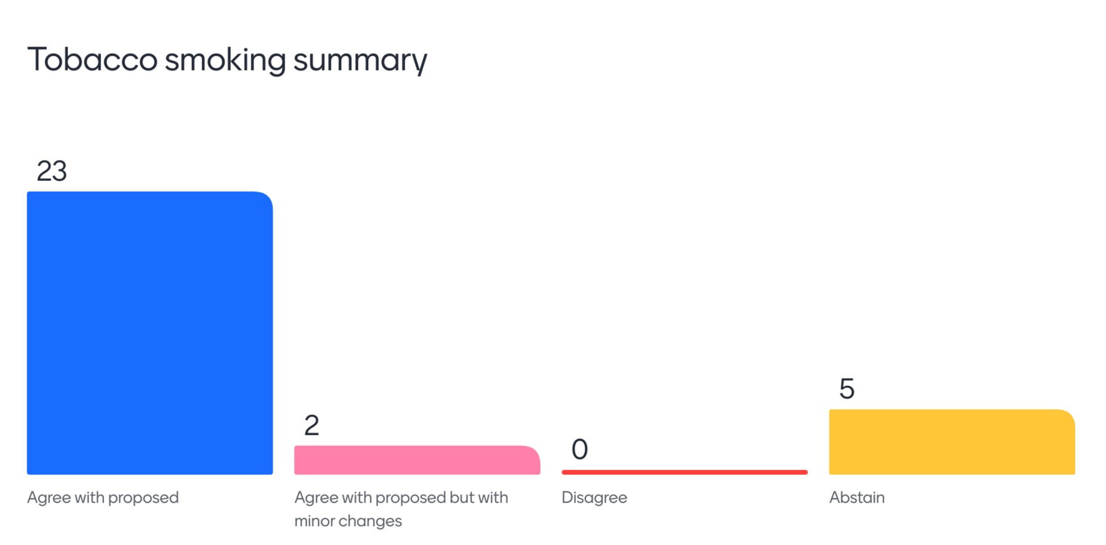
20241209-2D | Proposal of a data group for Alcohol Consumption Summary.  The data elements within the proposed data model are overall status, overall comment, and last updated | Majority voted to proceed with the proposed data model | 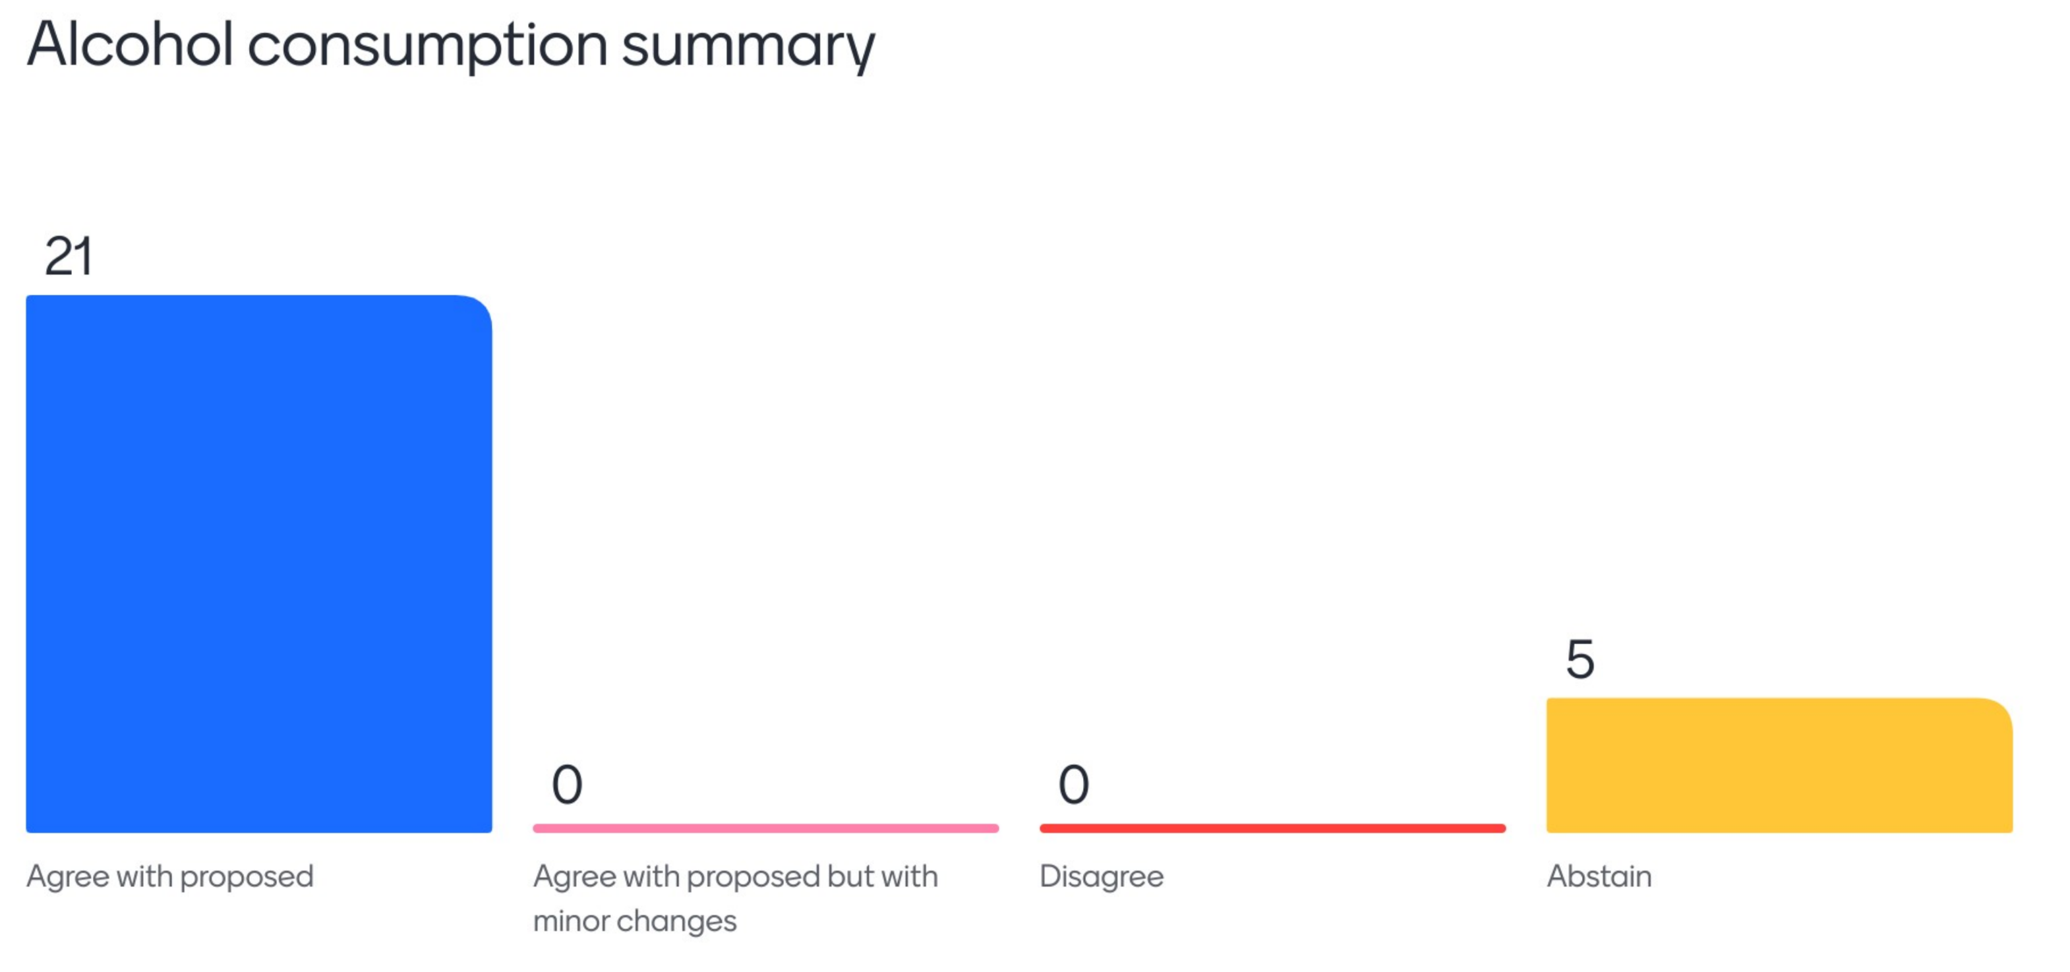
20241209-3D | Proposal of a data group to support substance use.  Data element includes: substance name, overall status, overall, comment and last updated. | Majority voted to proceed with the proposed data model | 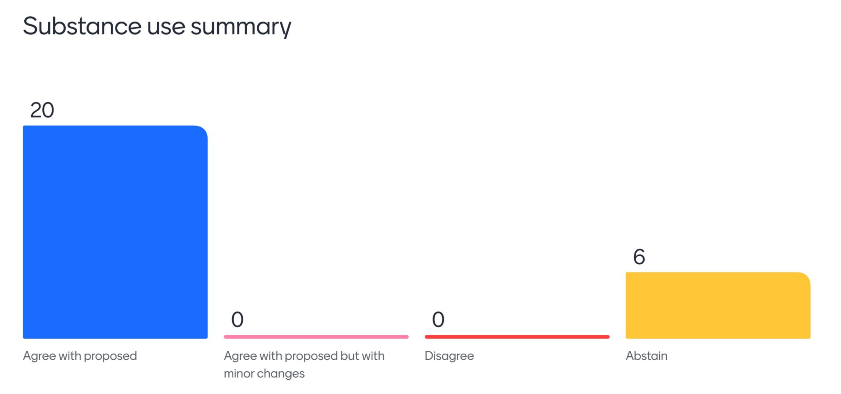
20241209-4D | Proposal of an initial data group to support recording of goal.  The data elements within the proposed model include goal name, goal description, clinical indication, start date, proposed end date, actual end date, outcome, comment, last updated which will be recorded once per goal | Majority voted to proceed with the proposed data model | 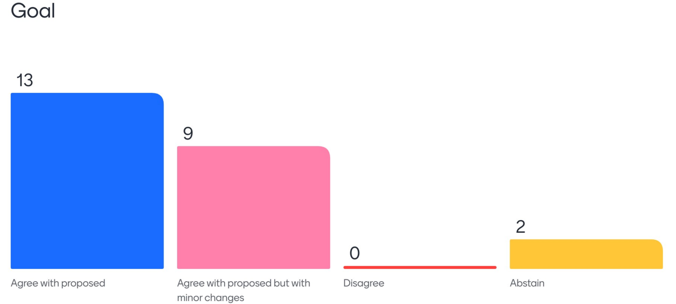
20241209-5D | Proposal of an initial data group to support recording of health issues.  The data elements within the proposed model include issue name, description, date of onset, last updated | Decision: Proceed with the proposed model for goals | 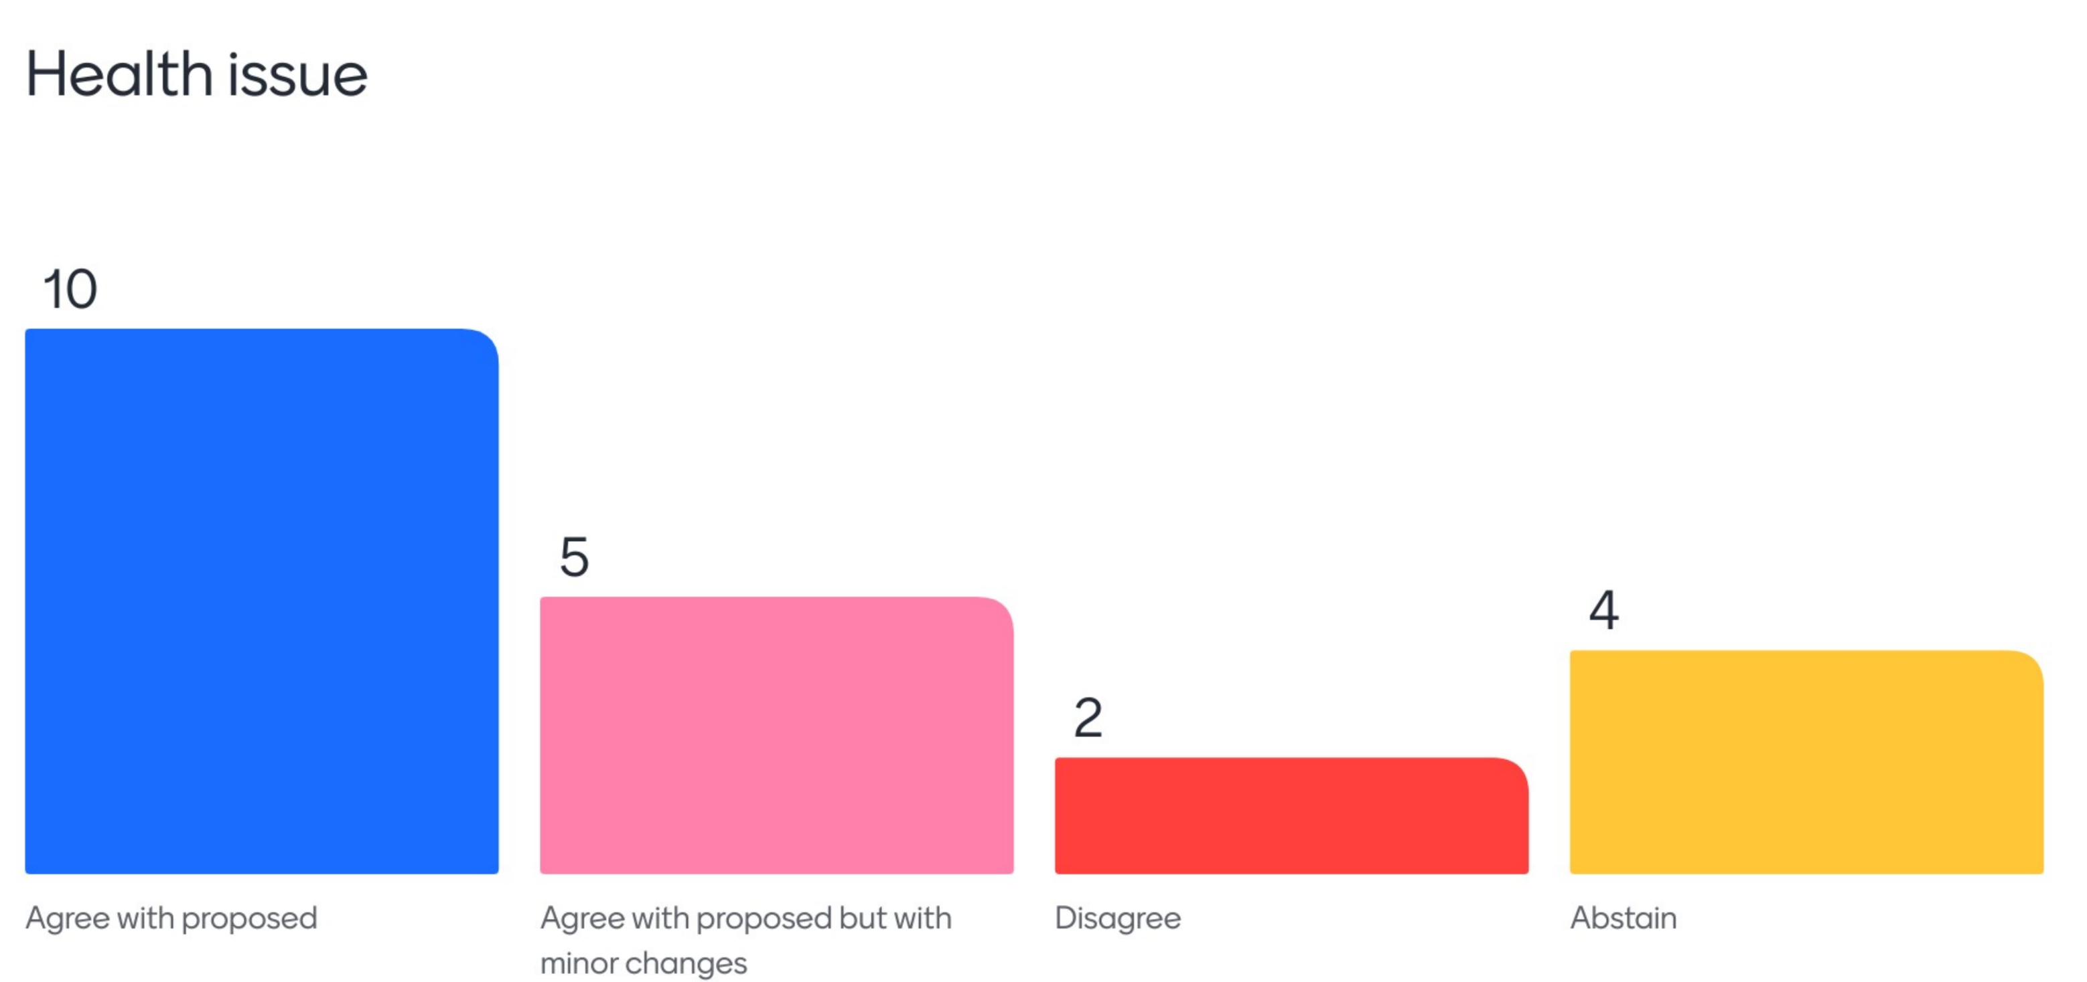

Actions
ID | Description | Responsible
2024129-1 | Share any definitions on what a health consideration/matter might be to help differentiate this from a health issue | All CDG Members
2024129-2 | Share proposals for SDOH, interventions and follow-ups with the group to receive feedback | Sparked Team
2024129-3 | Share feedback on the proposed data models for SDOH, interventions and follow-up | All CDG Members

Attendees

- Aleksander Stojkovski | - Kylynn Loi
- Alvin Lai | - Liam Rivett
- Andrew Donald | - Lily Shao
- Angus Millar | - Lisa Kalman
- Averil Tam | - Liz Keen
- Cailin Jordan | - Madison Black
- Carly Dober | - Michael Osborne
- Charlotte Hespe | - Michael Wilson
- Charlotte Howard | - Michelle Dobie
- Chris Moy | - Natalie Turner
- Dalisay Giffard | - Natasha Radcliffe
- Darrell Duncan | - Nicholas Ferris
- David Wiebe | - Nyree Taylor
- Deborah Wise | - Oliver Frank
- Desleigh Smith | - Olivia Carter
- Dusi Bojicic | - Peter Shandley
- Heath Frankel | - Rachel Hayhurst
- Heather Leslie | - Reg Cowie
- Jackie O’Connor | - Rob Hosking
- James Griffin | - Roisin Scully
- Janney Wale | - Sally Rees
- Jessica Brown | - Simon Gibson
- Jillian Kehoe | - Stephen Chu
- Karen Casella | - Steven Fullagar
- Karine Miller | - Susan Sheehan
- Katharine Bassett | - Tor Bendle
- Kim Drever | - Vicki Bennett
- Kimberley Hilton

