Minutes – Clinical Design Group Online Meeting 7

Meeting Details
Date | 15 October 2024
Time | 2:00pm – 4:00pm AEDT
Location | Virtual

Meeting Overview
Agenda Items | - Welcome and Acknowledgement of Country  - AU eReqDI R1 Update  - AUCDI R2  - Introduction  - Patient Summary  - Update from September CDG  - Patient Summary Proposed Updates  - Data Model Discussion  - Wrap Up and Close

Discussion Summary
Welcome and Acknowledgement of Country | Welcome  - Group welcomed  - Acknowledgement of Country  - Agenda Summary  - New email address – Sparked@csiro.au
AUeReqDI R1 Update | Update  - The CDG was presented with an AUeReqDI R1 community review report  - Aiming to publish R1 at the end of October
AUCDI R2 | Introduction  - The scope drivers for AUCDI R2 are patient summary, chronic disease management, and reason for encounter  - The scope drivers will be worked through iteratively, allowing for smaller, more focused feedback periods  - Patient summary out for public review in November, which will be open for six weeks, and chronic disease management component out for review in March.  Patient Summary & CDG Recap  - Updates to AUCDI to support AU Patient Summary for top 8 identified data groups from CDG F2F – adverse reaction risk, problem/diagnosis, problem diagnosis (past history of illness), procedure completed, vaccination administered, medication statement, sex and gender, pregnancy  - F2F CDG workshopped AUCDI R2 and its scope drivers, and eRequesting national terminology  - Activities and outcomes from CDG F2F are available on the Sparked website
AUCDI R2 Patient Summary Proposed Changes – No change | ‘No change’ overview  - It is proposed that the procedure completed event, vaccination administered, medication use statement, and sex and gender summary data groups and their respective data elements can be included in AUCDI R2 Patient Summary, without change, as they are included in AUCDI R1  Group Discussion  - At this stage, there is no ‘procedure type’ data element included in AUCDI R2 Patient Summary however, there is ‘procedure name’  - The medication use data element is used as a simple snapshot of what a patient is currently taking  - Sex assigned at birth will not change however, gender identity and pronouns can be dynamic and are able to be modified as necessary  - The medication use statement data model is used for each medication that the patient is on. Risk management and medication interaction regarding current medications being taken fits within the implementation guide. A data element to represent the start date for medication is in the backlog.  - The TDG is addressing requirements to ensure information will be exchanged with Medicare, including sex and gender information  - The procedure completed data model is the clinical representation of a procedure and is not addressing billing requirements as this is out of scope  - Representing no known data (e.g. medication, allergies) will be determined within the implementation guide which sits with the TDG  Majority voted to progress with these four data groups as the foundation for patient summary as published in AUCDI R1
AUCDI R2 Patient Summary Proposed Changes – ‘Enhancements’ | ‘Enhancements’ overview  - It is proposed that the adverse reaction risk summary and the problem/diagnosis summary data groups include additional data elements to what is published in AUCDI R1, for AUCDI R2 Patient Summary  Adverse Reaction Risk  - Adverse reaction risk summary includes additions of onset of first reaction and severity of reaction.  Group Discussion  - This data group covers the broadest range of substances to include  - The manifestation data element includes information regarding the signs that were evident that happened because of the exposure  - SNOMED is used as the basis for the severity of reaction and if this data element required additional values there is a non-breaking change that can be incorporated  - Representing the misidentification of a substance to cause an adverse reaction is in the backlog  Majority voted to agree with the presented proposal for the adverse risk reaction data group  ‘Problem/Diagnosis Summary’ overview  - Problem/Diagnosis Summary includes additions of date/time of onset and date/time of resolution  Group Discussion  - Under date/time of onset there is an inclusion of date/time clinically recognised in the backlog  - The date/time of onset data element allows for an age and/or period of time of onset as its uncommon to have an absolute start date  Majority voted to agree with the presented proposal for the problem/diagnosis summary data group
AUCDI R2 Patient Summary Proposed Changes – ‘New Data Groups’ | ‘New data groups’ overview  - It is proposed to add new data groups, last menstrual period (LMP), estimated date of delivery (EDD), menstruation summary, and pregnancy assertation, to AUCDI R2 Patient Summary  Last Menstrual Period (LMP)  - The proposed data elements for LMP include date of onset, certainty and date of assertion  Group Discussion  - The provenance of information (e.g. self-reported, clinical assertion) is defined for implementation with the TDG  Majority voted to agree with the proposed addition of the last menstrual period data group within AUCDI R2 Patient Summary  Estimated Date of Delivery (EDD)  - The proposed data elements for EDD include EDD by cycle, by ultrasound, date of ultrasound, gestation by scan, EDD by ultrasound, and last updated  Group Discussion  - The EDD will be removed from the patient record after the child is delivered or in the case of early pregnancy loss  - In the case of a scheduled caesarean section, the EDD can help to inform the date of this procedure  - A suggestion was provided to include natural delivery v. planned delivery to accommodate scheduled caesareans. Inclusion of a misuse section to outline that this is not to record the planned date and is an estimation based on clinical parameters may be beneficial  Majority voted to agree with the proposed addition of the estimated date of delivery data group within AUCDI R2 Patient Summary  Menstruation Summary  - The proposed data elements for menstrual summary include menstrual status and last updated  Group Discussion  - It was suggested to keep this information constrained to periods and add an addition element to record reproductive hormonal status  - Further definition within the data element about those forced into early menopause (e.g. breast cancer) is needed  Majority chose to abstain from voting on the proposed addition of the menstruation summary data group within AUCDI R2 Patient Summary  Further work required to understand the requirements and use of this summary.  Pregnancy Assertion  - The proposed data elements for pregnancy assertion include pregnancy assertion (pregnancy confirmed/pregnancy excluded), justification and date of assertion  Group Discussion  - If unable to ask or check the patient’s pregnancy status it is a null assertion  - If unable to check pregnancy status, the working hypothesis of ‘pregnant until proven otherwise’ is adopted  - To explain the context of the assertion a background description can be added to detail patient notes  - Some clinicians may find this challenging to assert in its current state with the ‘no’ and ‘excluded’ fields  - More discussion around pregnancy excluded is required  - If a patient presents and appears pregnant (enlarged abdomen/positive pregnancy test), their pregnancy status can be updated later with a new assertion separate to the assertion made on the initial consult  - Pregnancy assertion is only relevant at the specific point in time in which it is recorded  - Suggestion for wording to be ‘confirmed pregnant’ as the patient’s status rather than pregnancy which signifies a long-running event  There was no majority vote outcome on the proposed addition of the pregnancy assertion data group within the AUCDI R2 Patient Summary.  The main change requested by the CDG to what was proposed was changing the terminology used to “pregnant” rather than “pregnancy”
Next Steps and Upcoming Dates | Upcoming Events and News  - AUeReqDI Release 1 due to be published at the end of October  - 6 November Sparked 1-day roundtable – FHIRing up Interoperability in WA  - 20 November CDG F2F meeting in Melbourne

Actions
ID | Description | Responsible | Due
20241015-1 | Update contact for Sparked from FHIR@csiro.au to Sparked@csiro.au | All CDG Members | N/A
20241015-2 | Email through any comments or changes you suggest to any data groups voted upon in today’s CDG meeting | All CDG Members | 19/11/2024
20241015-3 | Speak to Australian menstrual experts to get their opinion and feedback on new data group, menstrual summary | Oliver Frank, Sparked Team | 19/11/2024

Decision Log
Decision ID | Proposal | Outcome | Menti
20241015-1D | It was proposed that the procedure completed event, vaccination administered, medication use statement, and sex and gender summary data groups and their respective data elements will be included in AUCDI R2 Patient Summary, without change, as they are included in AUCDI R1. | Majority voted to progress with these 4 data groups as the foundation for patient summary as published in AUCDI R1 | 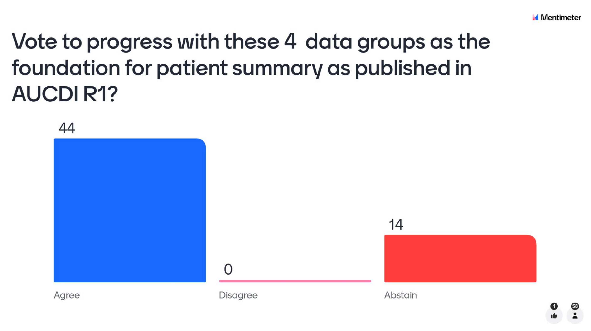
20241015-2D | It was proposed that the adverse risk reaction summary for AUCDI R2 Patient Summary includes the data elements from AUDCDI R1 with additions of onset of first reaction and severity of reaction data elements. | Majority voted to agree with the presented proposal for the adverse risk reaction data group. | 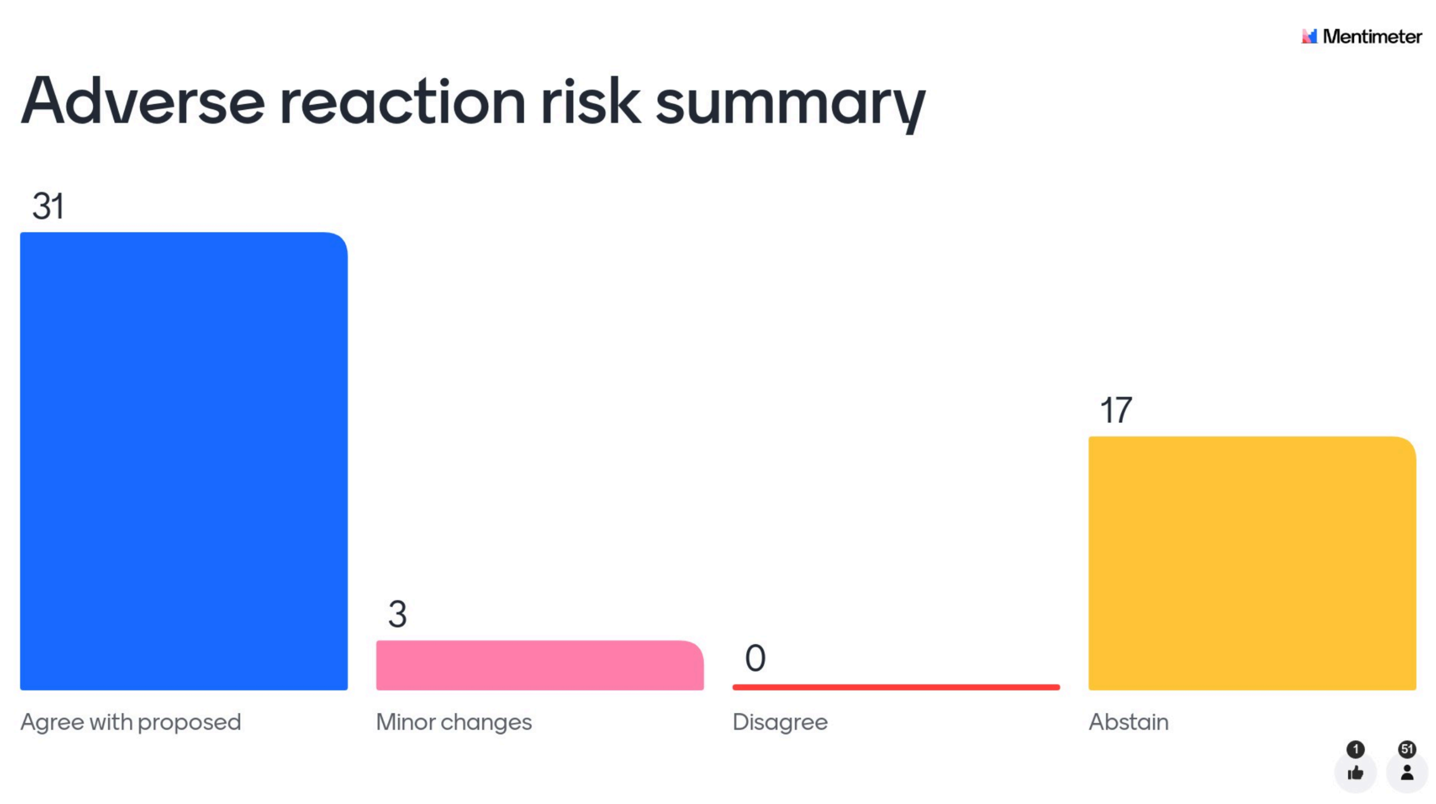
20241015-3D | It was proposed that the problem/diagnosis summary for AUCDI R2 Patient Summary includes the data elements from AUDCDI R1 with additions of date/time of onset and date/time of resolution data elements. | Majority voted to agree with the presented proposal for the problem/diagnosis summary data group. | 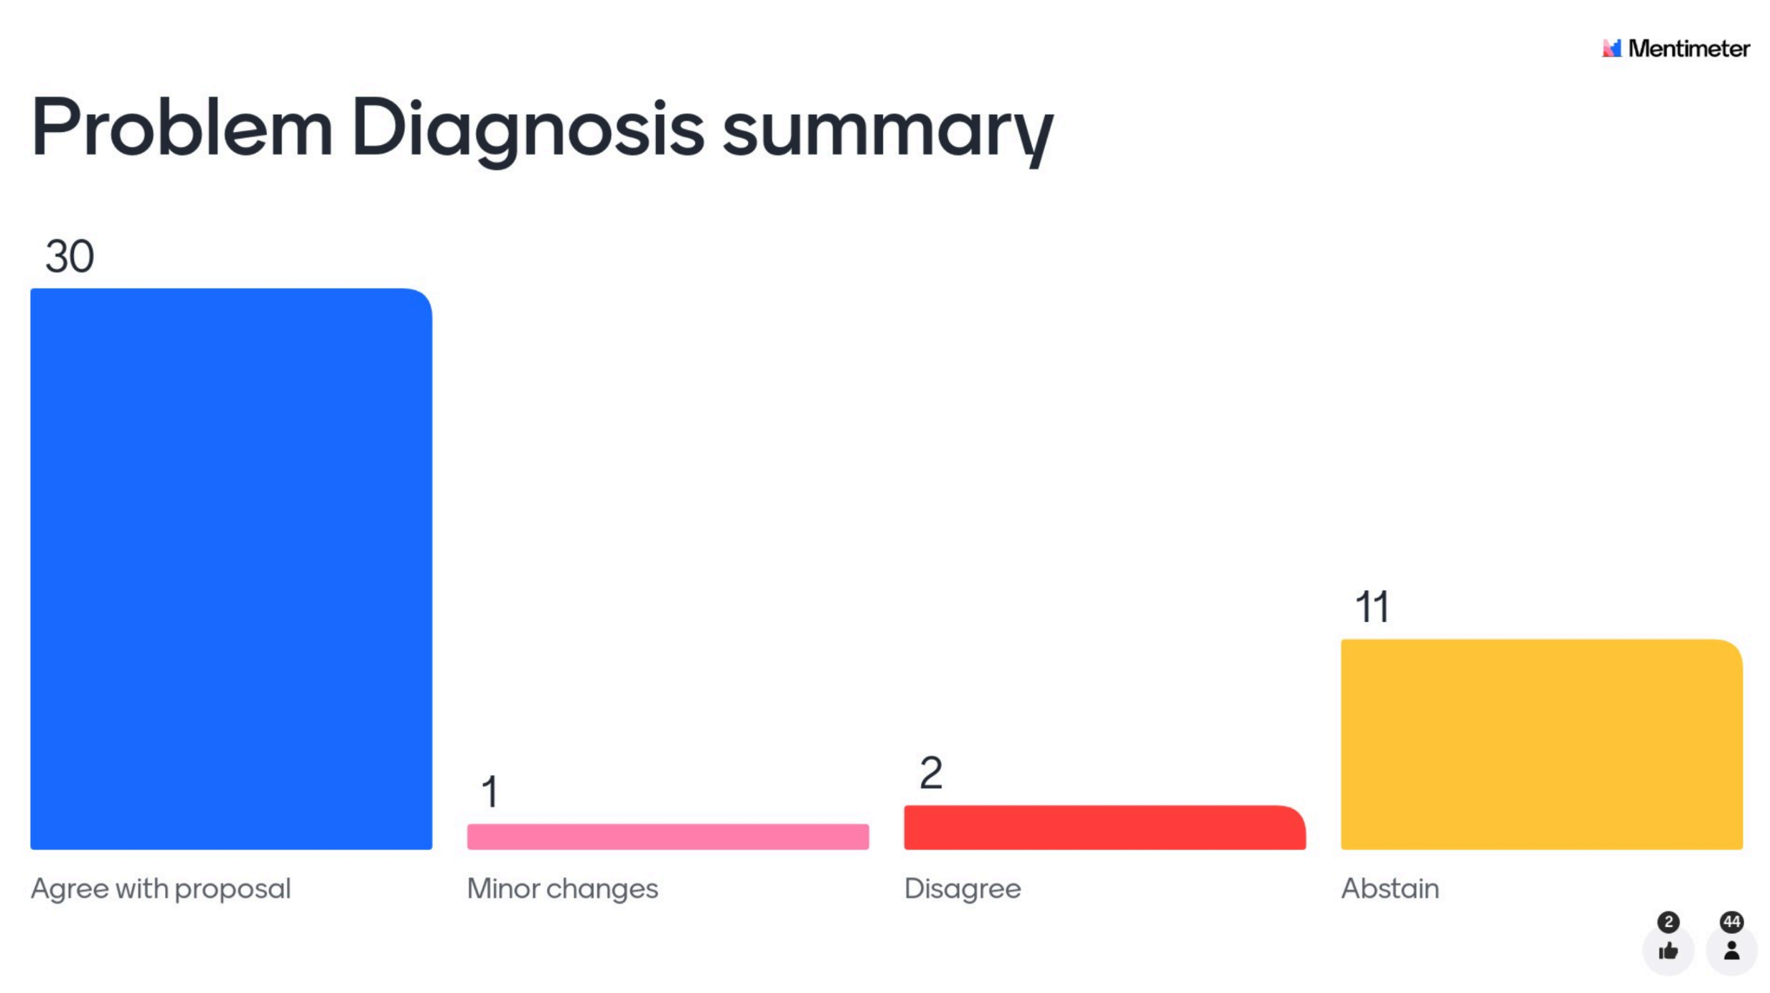
20241015-4D | It is proposed to add new data group, last menstrual period (LMP), to AUCDI R2 Patient Summary. | Majority voted to agree with the proposed addition of the last menstrual period data group within AUCDI R2 Patient Summary. | 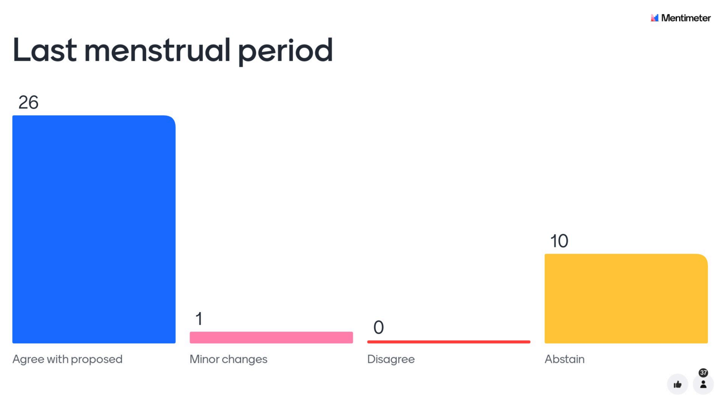
20241015-5D | It is proposed to add new data group, estimated date of delivery (EDD), to AUCDI R2 Patient Summary. | Majority voted to agree with the proposed addition of the estimated date of delivery data group within AUCDI R2 Patient Summary. | 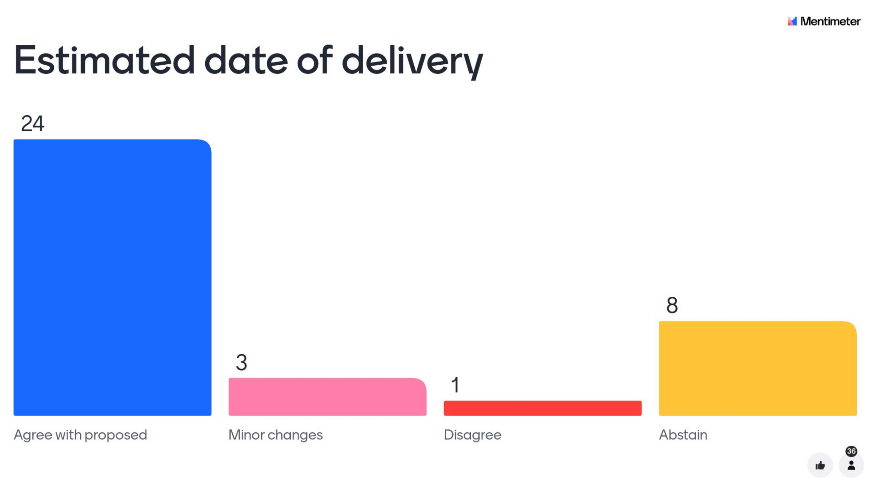
20241015-6D | It is proposed to add new data group, menstruation summary, to AUCDI R2 Patient Summary. | Majority chose to abstain from voting on the proposed addition of the menstruation summary data group within AUCDI R2 Patient Summary. | 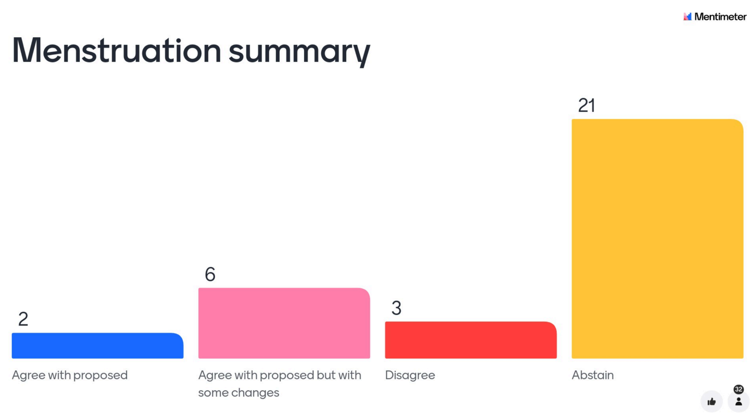
20241015-7D | It is proposed to add new data group, pregnancy assertion, to AUCDI R2 Patient Summary. | There was no majority vote outcome on the proposed addition of the pregnancy assertion data group within the AUCDI R2 Patient Summary. The after discussion, there was a majority for agree or agree with changes – the main change requested to the proposal was changing the terminology used to "pregnant” rather than pregnancy | 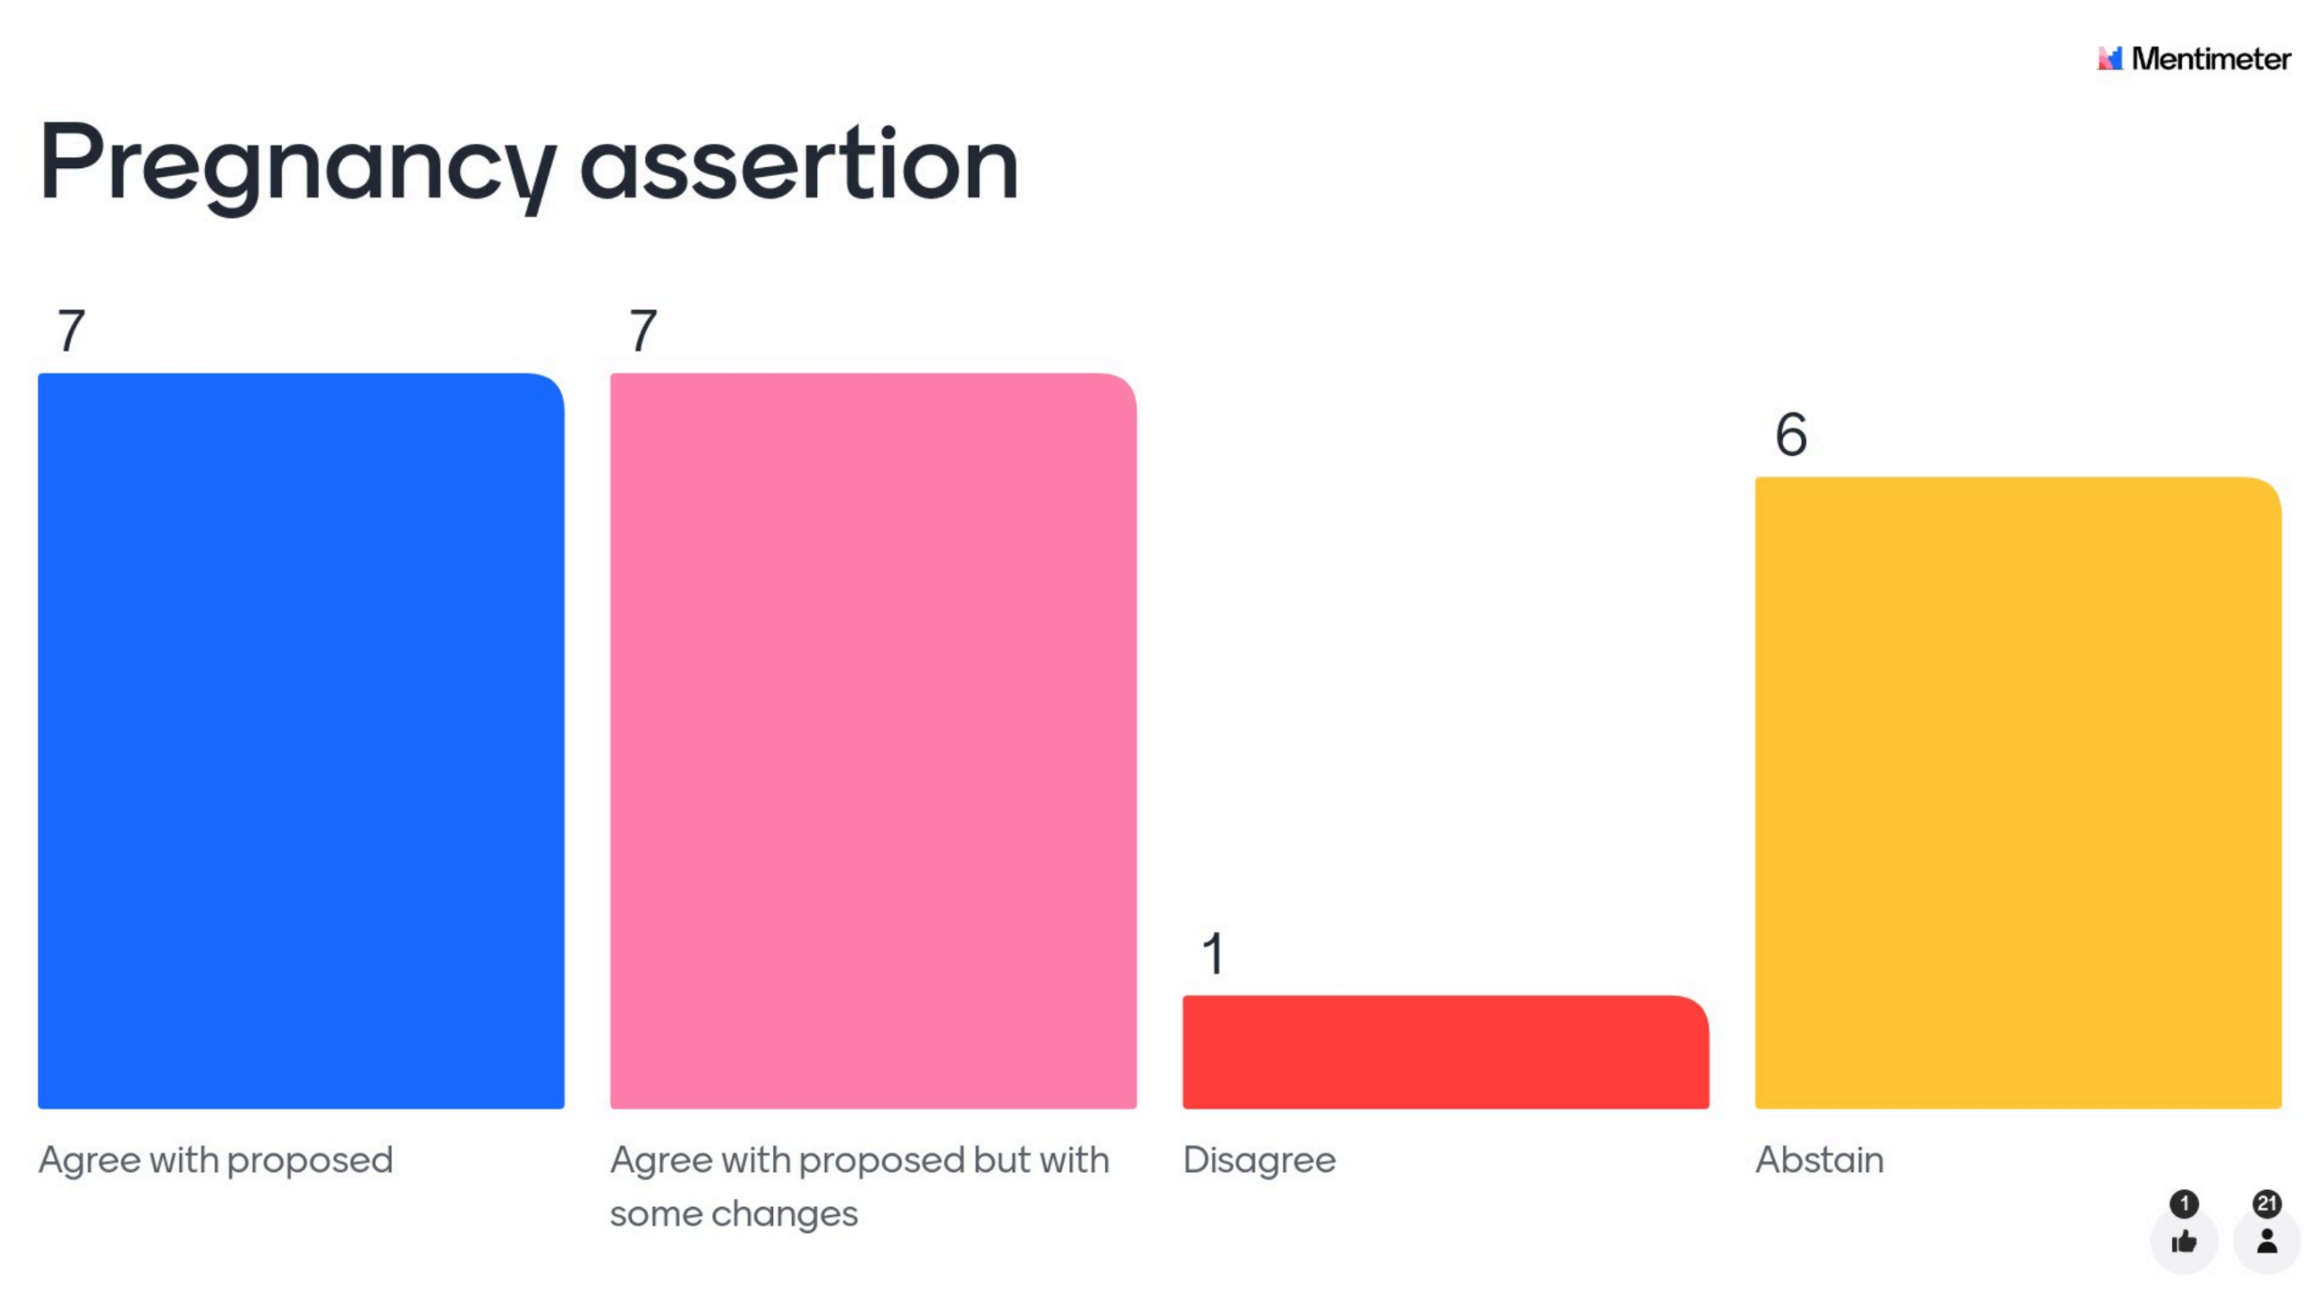

Attendees
- Madison Black | - Kylynn Loi
- Heather Leslie | - Olivia Carter
- Chris Moy | - Shelley Behen
- Michael Osborne | - Tor Bendle
- Danielle Tavares-Rixon | - Jing Jin
- Andy Bond | - Lana Briers
- Jeffrey Chen | - Alvin Lai
- Susan Sheehan | - Aleksandar Stojkovski
- Natalie Turner | - Heath Miller
- Louise Jackson | - Maxwell Holmes
- Alan Soewargo | - Desleigh Smith
- Oliver Frank | - Murray
- Sinclair Hughes | - Kimberley Hilton
- Carey Campbell | - Christy Sieler
- Shar O’Dea | - Avantika Sharma
- Dianne Brown | - Victoria Fitzgerald
- David Wiebe | - Michelle Dobie
- Shelley Thomson | - Natasha Millerd-Stevens
- Stephen Chu | - Dusica Bojicic
- Francis Lee | - Andrew Donald
- Paul Frosdick | - Min Anne Tan
- Sanjeed Quaiyumi | - Sari McKinnon
- Jaymee Murdoch | - Maybelle Auw
- Jordan Tapusoa | - Rosemary Velardo
- Kiran Matta | - Chaturica Athukorala
- Jackie O’Connor | - Liang Wang
- Natasha Radcliffe | - Andrew Matthews
- Paris Majot | - Liam Rivett
- Owen Katalinic | - Stuart Hanson
- Lily Shao | - Liz Keen
- Kathleen Rogers | - Kevin Zheng
- Bonnie Smith | - Joanne Sippel
- Nicholas Ferris | - Lyle Turner
- Bojan Pijetlovic | - Melissa Holmes
- Sally Rees | - Iurie Brinister
- Karine Miller | - Todd Miller
- Suki Loe | - Darius Wey
- Joel Tuccia | - Kambiz Bahaadinbeigy
- Michael Hosking | - Kim Drever
- Reg Cowie | - Suraj Kandel
- Lisa | - Josh Hare
- David Evans | - Riley Bartholemew
- Deborah Wise

