Minutes – Clinical Design Group Online Meeting 9

Meeting Details
Date | 23 January 2025
Time | 2:00pm – 3:30pm AEST (Brisbane time)
Location | Virtual

Meeting Overview
Agenda Items | - Acknowledgement of country  - AUCDI Update  - Patient Summary Update on AUCDI R2 Patient Summary – Request for feedback by 31 Jan 2025  - AU Patient Summary FHIR IG Project – Update  - Chronic Condition Management  - Recap of last CDG  - Interventions and follow-ups  - Social Determinants of Health Pattern  - Upcoming events

Discussion Summary
AUCDI Update | AUCDI Update  - AUCDI R1 has been published and we are currently in the middle of R2  - The three topics of focus for AUCDI R2 include patient summary, chronic condition management and reason for encounter  - The final AUCDI R2 will be published in June  - AUCDI R2 Patient Summary iteration is currently out for community review with feedback due 31 Jan 2025  Clinical Focus Group Update  - The first meeting back for 2025 will be held on 5 February 2025 and will focus on developing clinical scenarios and test data to support the existing patient summary consumer journeys  - The feedback window for the patient summary consumer journeys closed 17 January however, it is still available to view on the Sparked website and any additional feedback can be submitted to the sparked team via sparked@csiro.au
Chronic Condition Management | Recap of previous CDG  - In the previous CDG meeting, the group reviewed the health behaviour proposals and additional changes made to those data groups. Data groups included tobacco smoking summary, alcohol consumption summary, substance use summary and new data groups, goal and health issue. For further information see a full breakdown in the slide pack on the Sparked website.  Care Plans  - The care group data plans have been defined through components of a care plan including the aim, what needs to be done, and what was done. These data groups are goal data group, service request data group, procedure completed data group and vaccination administered data group.  Interventions – what was done  - This term was put out to the community to receive their feedback on what it means, and a broad range of interpretations were recorded  - In December a request for feedback was put out for the proposed intervention definition and from the 9 responses received, it has been refined  - Menti – do you agree with the proposed definition for an intervention?  - Agree with proposed - 17  - Agree with proposed but with minor changes - 3  - Disagree - 1  - Abstain – 2  - Majority have voted in favour of the proposed definition for intervention  - Group discussion  - Update the definition to include ‘support’ as part of the preliminary definition – “A single therapeutic activity, or a series of activities, intended to prevent, diagnose, treat, manage, or support health conditions…”  - The inclusion of the word ‘diagnosis’ may be problematic as an intervention is typically in response to a prior screening/diagnosis. However, in the context of emergency medicine or acute care, interventions can occur in response to clinical indications without a specific diagnosis  - The current intervention definition is dependent on the definition of an activity. This can be accepted as a broad definition, but with further discussion to be had surrounding what constitutes an ‘activity’  - ‘Procedure (completed)’ and ‘Vaccination (administered)’ data groups are already part of AUCDI however, intervention needs expansion to include not only what was done, but also what is planned  - The additional proposed data groups for intervention include ‘health education (provided), ‘medical equipment (provided)’, ‘psychosocial therapy (provided)’ and ‘physical assistance (provided)’  - Group discussion  - Is there potential to split the psychosocial category or further clarify the name of this category  - Psychosocial care also fits into different care applications outside of explicit mental health contexts (such as allied health) which follow a biopsychosocial model of care, with the utilisation of psychosocial care methods in patient treatment being strong predictors of health outcomes  - For the purpose of standardisation, the data group name is kept broad however, the display name of the data group may be displayed differently to clinicians for clarity in different contexts (GP/allied health) with the information being stored in the same place  - The request for CBT and the place where completion of CBT is recorded will be within the service request data group to close the loop within the care plan  - Physical Assistance  - Support or care provided by carers to help individuals perform tasks  - Group Discussion  - Proposed change to physical assistance to assistive/supportive care as this can accommodate both assistive requirements beyond just physical ailments – e.g. a patient with intellectual disability who requires someone to communicate on their behalf  - Physical recovery/support such as a home exercise plan prescribed by a clinician, (e.g. physiotherapist) will fall within a different data group  - Further definition around whether remote patient monitoring is included as patient assistive support  - The care plans can include ad-hoc administration of medication that differs from the prescription under a specific set of circumstances -e.g. asthma patient  - Menti: Do you agree with including each of the proposed concepts in AUCDI R2? *Note: physical assistance is assumed to be updated to supportive assistance for the purpose of the vote  - Ranked on a scale with 0 being disagree and 3 being agree  - Health education – 2.9  - Provision of medical equipment – 2.9  - Psychosocial therapy – 2.9  - Physical assistance (supportive assistance) – 2.8  - Majority agreed with the inclusion of the proposed concepts  - Menti: What other intervention concepts have we missed?  - Responses: apps wearable to monitor, physical exercise program, enteral feeds, telehealth, dietary advice, coordinating, carer administrated, physical therapy, self-administered medication, emergency action plan, preventative, referring, manual therapy, supportive digital tech, home rehab programs, holistic  Intervention Patterns  - We are beginning at the core of the core with simple and bare patterns  - Pattern - <XYZ concept> includes a concept name and the specific intervention name/type for that concept, a free-text description and the date on which it was done  - Group discussion  - The date of proposed and completed intervention will be recorded within the service request  - The attributes of a patient (e.g. elderly, paediatric) may be useful to capture for health education interventions  - Further definition on how to record or judge whether an intervention was effective or what the outcome was. This has been put onto the backlog  - Menti vote: Do you agree with the proposed pattern to model interventions?  - Agree with proposed – 13  - Agree with proposed but with minor changes – 4  - Disagree – 0  - Abstain – 2  - Majority have voted in favour of the proposed pattern to model interventions  Intervention: Procedure Completed Revisited  - It is proposed to enhance the existing AUCDI R1 procedure completed to include a description data group.  - This data element will be free text  - Menti: Do you agree with the proposed update to procedure completed from AUCDI R1  - Agree with proposed – 13  - Agree with proposed but with minor changes – 0  - Disagree – 0  - Abstain – 0  - Majority agree with the proposed update  Essential Care Plan Components  - The definitions for follow-up, recall, and reminder have been updated with the feedback received  - Group discussion  - The language ‘action’ in the recall definition may be too broad and should include more explicit wording around patient/clinician contact (e.g. the clinician contacts the patient to bring them back)  - The recall definition needs an inclusion of reasonableness, as not all contact attempts between clinician and patient are successful. It should include language around reasonable attempts made to contact patients  - Add “facilitate the timely completion of a specific health related task or convey information” or something to that effect to address potential appointment preparation (e.g. colonoscopy prep)  - A reminder is a significant part of preventative healthcare, and is utilised for routine/planned care, like vaccinations, where there is no specific concern for the patient’s care. This should be addressed in the definition  - The wording clinician-initiated within the recall definition aims to define that the recall is driven by a clinician’s decision  - Reminders help to convey the treatment plan to the patient is this is not effectively done currently  - Offline voting and a request for feedback following updates and changes from today’s discussion  Social Determinants of Health  - Social determinants of health are the conditions in which people are born, grow, live, work and age. We are determining how this can be recorded in electronic health records  - “Summary” data groups, one per clinical concept  - Pattern 1 - <xyz concept> data groups: description (narrative), last updated  - Proposed concepts for pattern 1 include living arrangements summary, occupation summary, sexual health summary, physical activity summary, gambling summary, education summary  - Pattern 2 - <xyz concept> data groups: description (narrative), status, last updated  - Proposed concepts for pattern 2 include food and nutrition summary, housing summary, financial summary, personal safety summary  - Group discussion  - There may be no accepted way of capturing the SDOH within the electronic health record as this has not been routinely captured  - The summary will show that the information exists and when it was recorded and then further detail can be sought  - If clinicians are able to understand this information, it can help to determine the best and most accessible clinical care plan for the patient  - Consideration should be made when recording this information about how the patient wishes to be spoken about and if this information can be shared amongst the care team, with the goal to avoid stigma or bias  - Menti: Do you agree with the proposed approach of using the two patterns to model the identified SDOH?  - Agree with proposed – 13  - Agree with proposed but with minor changes – 0  - Disagree – 0  - Abstain – 1  - Majority agreed with the proposed approach of two patterns to model SDOH  - Menti: Do you agree with including each of the proposed concepts in AUCDI R2?  - Ranked on a scale with 0 being disagree and 3 being agree  - Living arrangements summary – 2.6  - Occupation summary – 2.7  - Sexual health summary – 2.5  - Physical activity summary – 2.9  - Gambling summary – 2.3  - Education summary – 2.6  - Food and nutrition summary – 2.9  - Housing summary – 2.7  - Financial summary – 2.5  - Personal safety summary – 2.8  - Majority agree with including the proposed concepts in AUCDI R2  - Menti: Are there other SDOH we should add to our backlog for future development?  - Responses: adl – used for population, family support availability, language, employment, social connection, activities of daily living, country of origin, location, interpreter
AU Patient Summary FHIR IG Project – Update | Postponed to a future meeting
Wrap Up | Upcoming Events and Releases  - AUCDI R2 Patient Summary Update on AUCDI R2 Patient Summary – 31 Jan 2025  - Next Face-to-Face meeting in Adelaide - 19 Feb 2025  - Next part of AUCDI R2 (Chronic Condition Management) out for review in March

Decisions
Decision ID | Proposal | Outcome | Menti
20250123-1D | Proposal for a definition of intervention  Definition Proposed:  A single therapeutic activity, or a series of activities, intended to prevent, diagnose, treat, or manage health conditions, support mental or physical well-being, or address social and environmental factors that influence health outcomes. | Majority have voted in favour of the proposed definition for intervention | 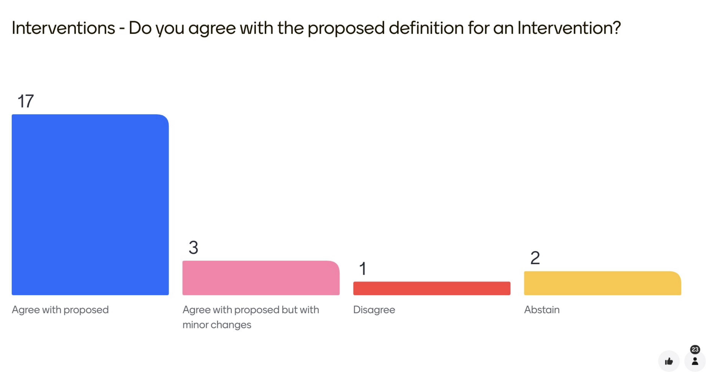
20250123-2D | Proposal of 4 data groups (health education, provision of medical equipment, psychosocial therapy and physical/supportive assistance) to support interventions on the generic intervention diet | Majority agreed with the inclusion of the proposed concepts | 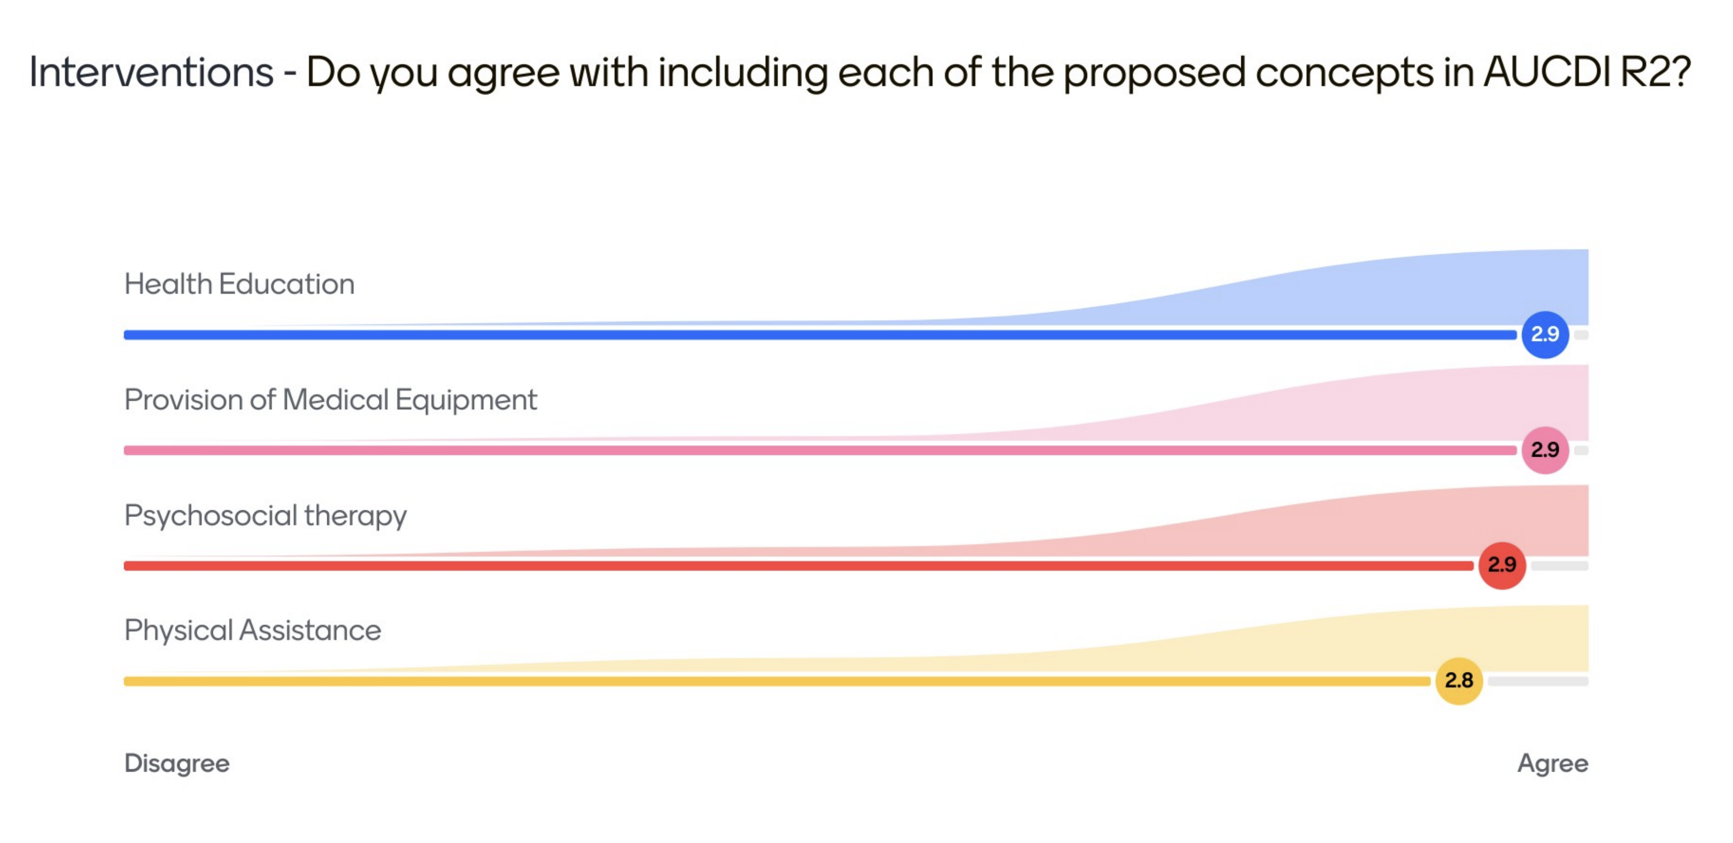
20250123-3D | Proposal of a generic intervention pattern to be used for Intervention concepts in AUCDI - <XYZ concept> includes a concept name and the specific intervention name/type for that concept, a free-text description and the date on which it was done. | Majority have voted in favour of the proposed pattern to model interventions | 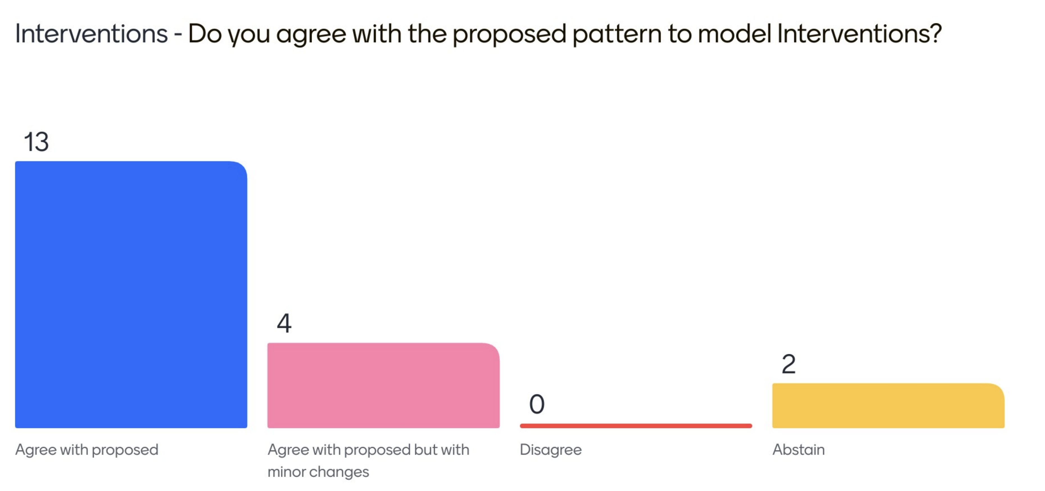
20250123-4D | Proposal to enhance the existing AUCDI R1 procedure completed to include a description data group. | Majority agree with the proposed update | 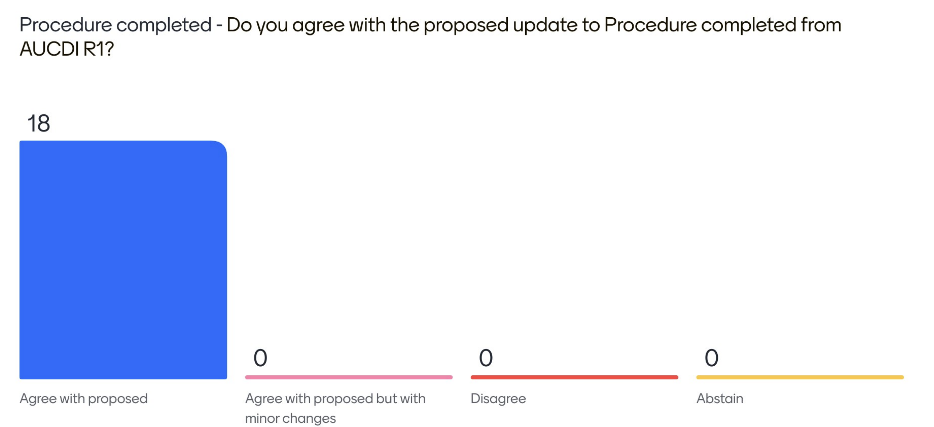
20250123-5D | Proposal to include Living arrangement summary,  Occupation summary,  Sexual health summary,  Physical activity summary, Gambling summary,  Education summary,  Food and nutrition summary,  Housing summary,  Financial summary,  Personal safety summary in AUCDI R2 | Majority agree with including the proposed concepts in AUCDI R2 | 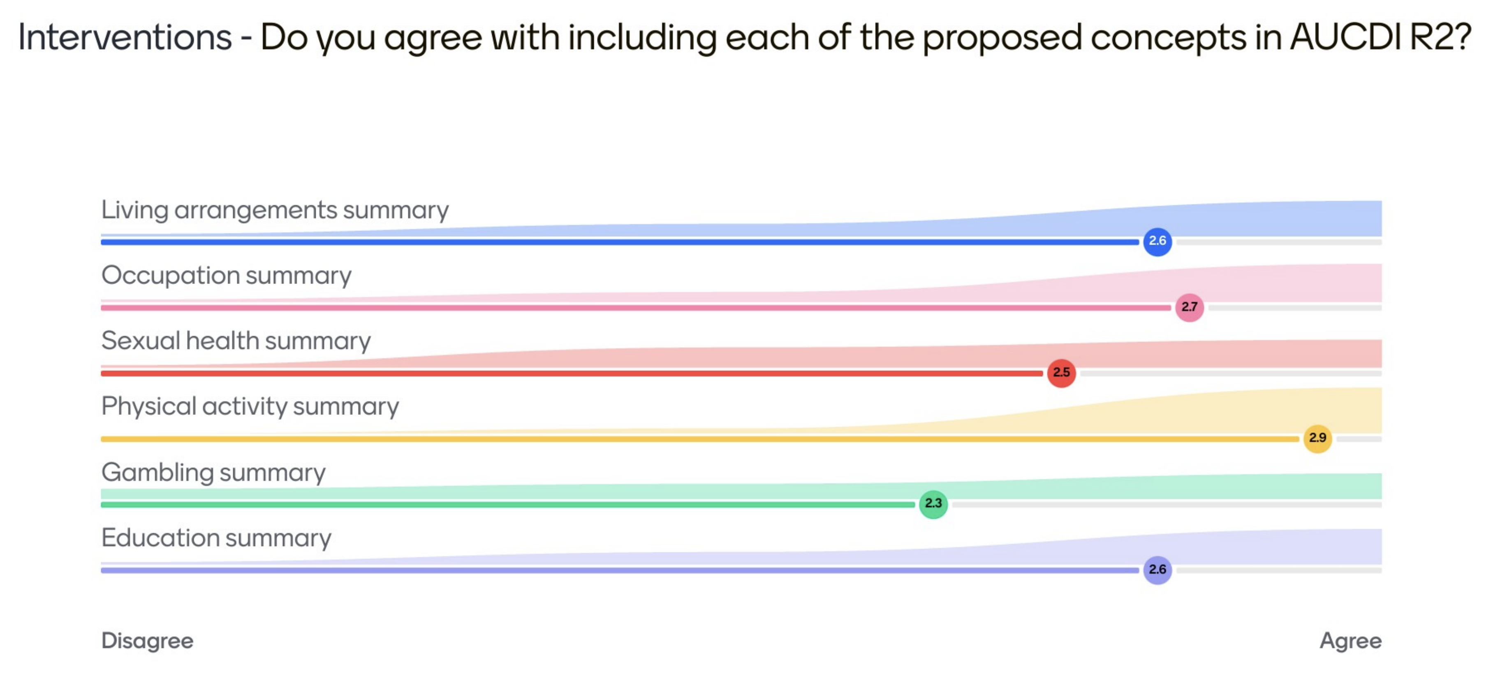  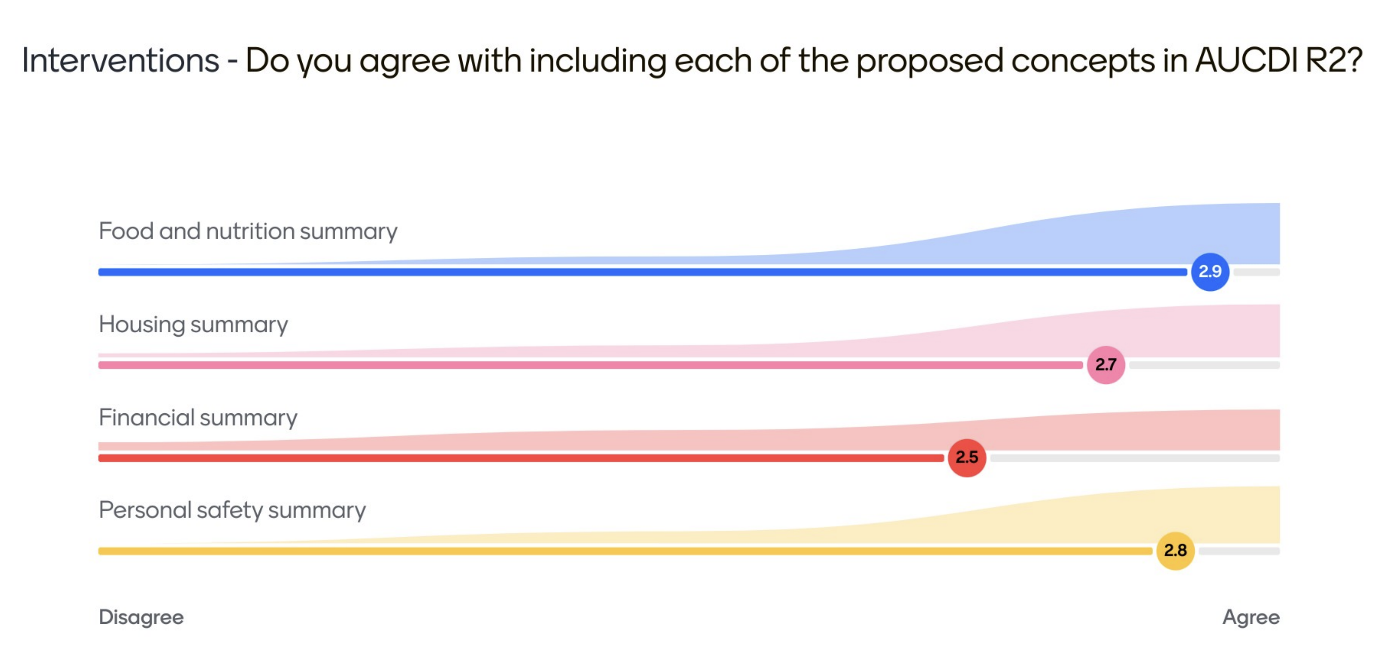
20250123-6D | Proposal of approach of using two patterns to model SDOH content for AUCDI. | Majority agreed with the proposed approach of two patterns to model SDOH | 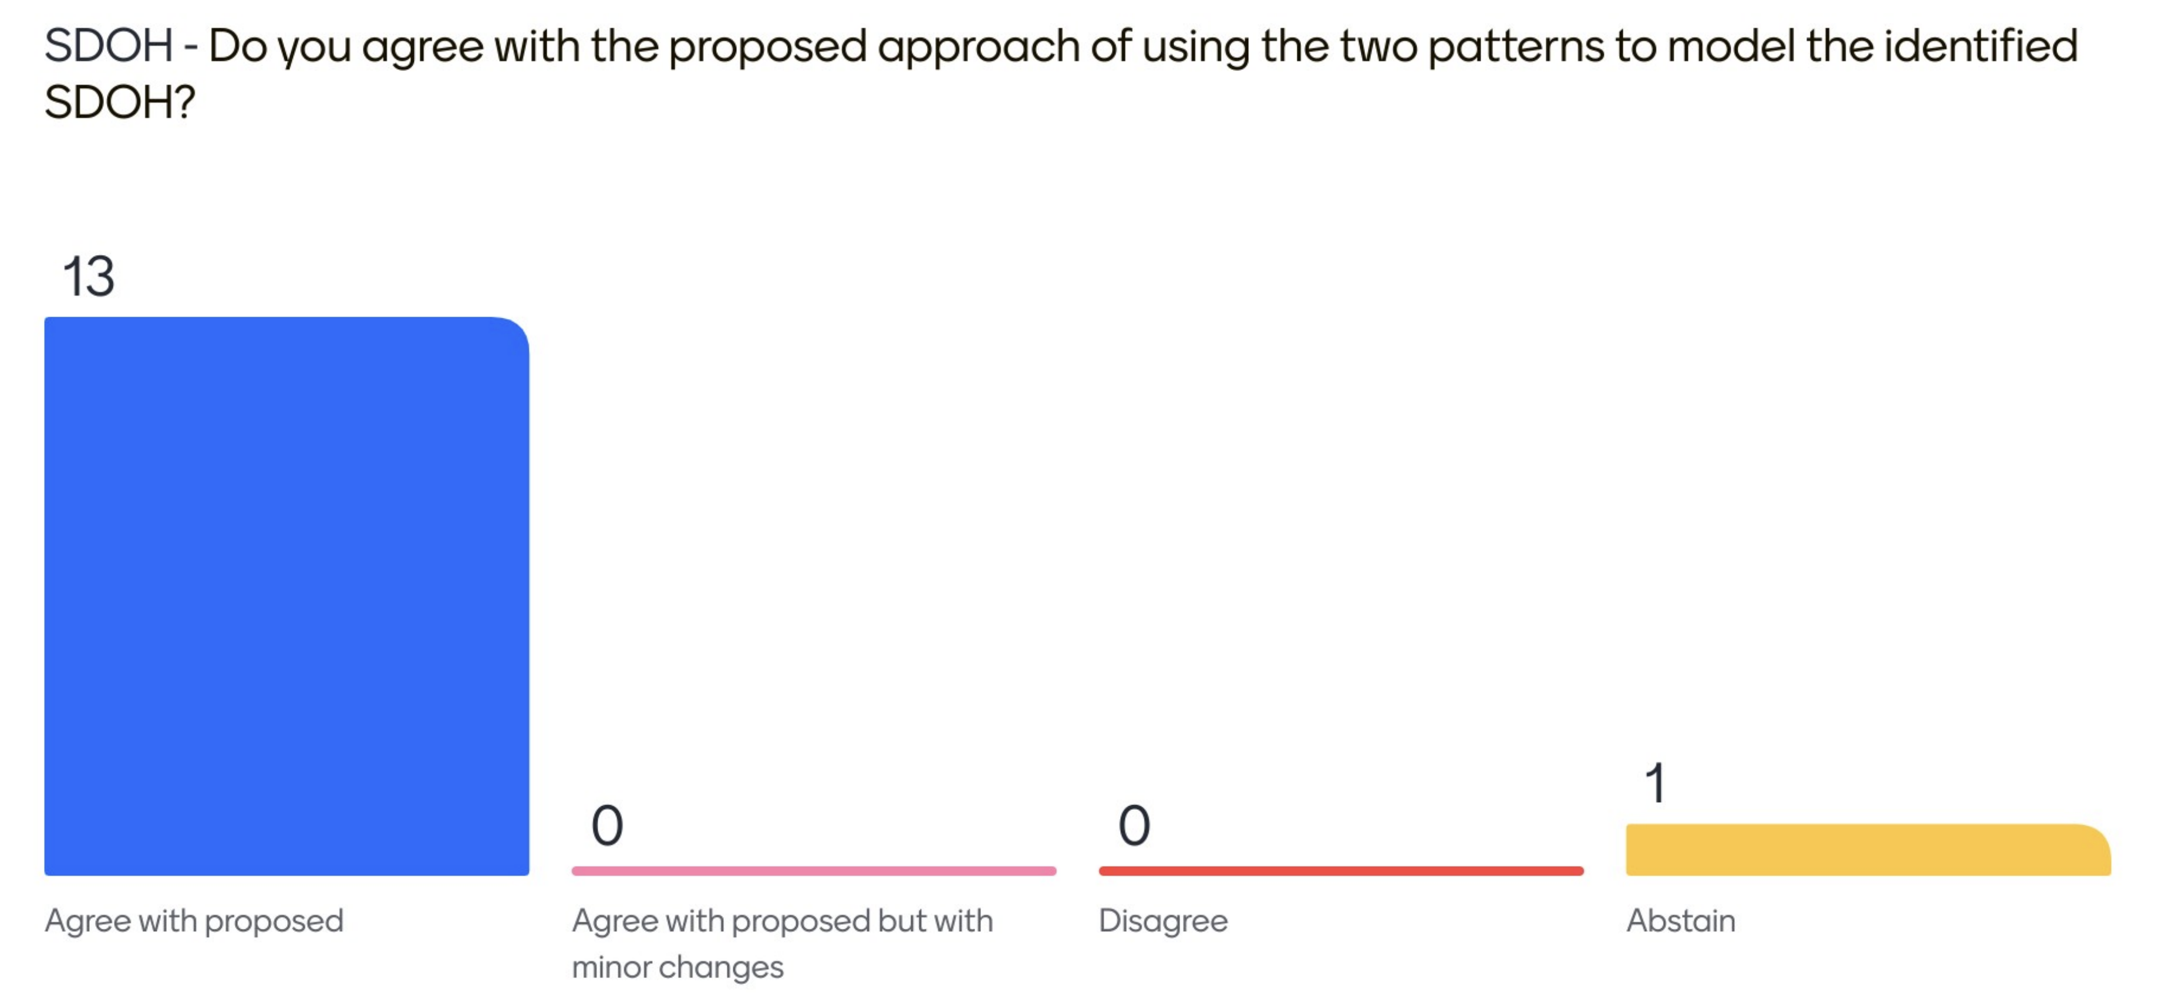

Actions
ID | Description | Responsible
20250123-1 | Share proposed names for physical assistance intervention data group | Sparked team, HI-M
20240123-2 | Share any additional intervention components you believe may have been missed | Sparked team, CDG members
20240123-3 | Share offline vote and feedback requests with the CDG regarding follow-up, recall and reminder definitions | Sparked team, CDG members

